School Growth Planning Process
School Name: Porter Creek Secondary School

P Porter Creek Secondary School is a grade 8 to 12 secondary school in the Porter Creek community of Whitehorse. Porter Creek’s population is approximately 460 students. Students come from both urban and rural settings. We have variety of
School Profile:

P Approximately 39% of Porter Creek Secondary Schools population self-identify as First Nations. 16.5% of PCSS students have Individual Education Plans, and another 14% of the students have Student Learning Plans or are on our Monitor list. These numbers do not include the students in our Shared Resource Room (Life Skills). 72.5 % of Porter Creek Students live outside the immediate neighbourhood and either take the school bus, or city bus.
1

School Demographic:

- Vision Statement (2014/215) – Enriching lives through Learning
Mission Statement (2014-2015) – Through collaboration and support, the PCSS community will foster resiliency and integrity of all learners.
School Vision & Mission:

Schools Commitment to First Nation Ways of Knowing & Doing:

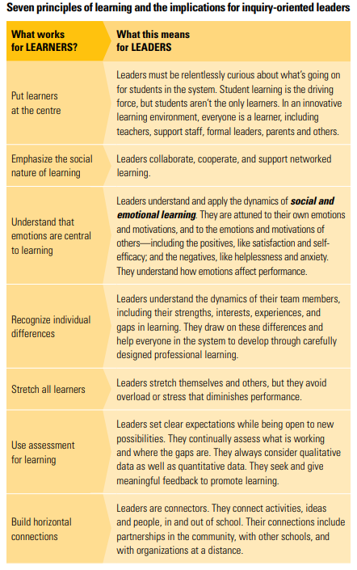
School Growth Plan
Using the Spiral of Inquiry to Develop Your Plan (Halbert, Kaser and Timperley, 2012)
The school develops a school growth plan for growth using the Spiral of Inquiry framework to inform the process.
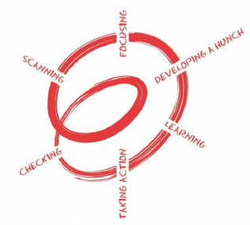

Scanning: What’s going on for our learners:
- Using data from a variety of sources including the initial Class Review, teacher observations and evidence of student learning, the team scans their learners.
Focusing: What will give us the greatest impact for student learning?
- Examining the scanning data, the team highlights areas of possible focus in professional learning.
- Begin by choosing one area of focus that will have the greatest impact on learners and learning.
- Is the area of focus big enough?
- Will it really make a difference?
Developing a Hunch: How are we contributing to the issue?
- The team considers the ways in which we, as educators, may be contributing to
- the selected area of focus.
- What are our biases?
- Are there other factors which contribute?
- What can we directly impact and change?
New Professional Learning: How and where can we learn more about what to do?
- What are the resources that can further my learning in the area I have chosen to focus?
- Books, research literature, professional learning networks and colleagues, Professional Development days are all possible sources of new professional learning.

Taking Action: What will we do differently?
- After the team develops the inquiry focus and considers new professional learning to help frame how to change teaching to better meet the needs of learners.
- This stage involves thoughtful planning and set up in the weeks before the Learning Round- what teaching and learning practices are being explored or deepened?
- A schedule is established for meetings and to consider how reflective practice will be incorporated.
- Roles for the team members are established, ensuring that the Principal or Vice-Principal is involved in supporting teacher professional growth.
Checking: Have we made enough of a difference?
- By examining evidence of student learning, and examining the initial focus and baseline observations and data, the teacher and the tea, ask themselves: How have students improved? Has my teaching made (enough of) a difference? Using the spiral of inquiry, do we need to revisit the focus? The new learning?

School Growth Plan Outline
- Scanning:
Briefly summarize your scanning process. How did you use the Class Review, observations, four key questions as part of the scanning process? What did you notice about the experiences of your learners that were most important to your team? How did you use the OECD 7 Principles of Learning and the First Peoples Principles of Learning in your scanning process?
Our School Surveys
  - School and classroom context
  - Students feeling safe and belonging to the community
  - Anxiety
  - Positive student use of technology
Teacher anecdotes about how they are using First Nations ways of knowing and doing.
Relationship building: Who am I and Where do I come from?
Greater need to see what students are accomplishing in programs such as Band, Guitar, FADS, Art, SASE.
Students in community: Pride that we haven’t necessarily acknowledged at school.

- Focus:
In a few sentences, explain why you have selected this area. What changes are you hoping to obtain for your teachers?

As a collective we need to embed First People’s ways of Knowing and Doing in our school fabric. We would like to enhance learners sense of self and place and focus on our sense of pride.
Provide confidence and expertise for staff.

- Hunch:
Describe your hunches about the ways in which your practice or practices at the school may contribute to the experiences of your learners.
By increasing Pride we will enhance Porter Creek’s learners sense of self and place.
Recognition of knowledge and accomplishment will increase sense of self and place.
Bias to recognize are:
- First Nations ways of knowing a doing are just for First Nations students
- Public has a negative perception of PCSS
- If we don’t know it can lead to misunderstanding
In order to have an impact and change we have:
- Teacher expertise
- Celebrations
- Relationship building amongst teachers and students

- New professional learning:
What new areas of professional learning do you plan to explore? What resources may be helpful? What specific tools will you use for your professional learning to support the learning of your students?
Explore the depth of culture recognizing the cultural Iceberg.
Peter’s feedback from staff survey.
IGNITE – two to three minutes mini-presentations

- Taking action:
Describe the strategies you and your team will use. How will learning rounds be structured and support your learning?
Within departments:
- Address School Inquiry question
- Use spiral of Inquiry to look at the question
- Individual teachers use the question in their Professional Growth Plan

- Checking (after taking action, or in debriefing in Learning Rounds):
Summarize the differences you made. Were they enough? Were you satisfied? What did you use as baseline- and change- evidence? How much richer are your learners’ answers to the four questions?

- Reflections/Advice:
Finish by sharing what you learned from this inquiry, where you plan to go next, and what advice you would offer other schools with similar interest.

