PORTER CREEK SECONDARY SCHOOL

August 2022 – June 2023 School Calendar

Principal: Ms. Nicole Cross
Vice Principal: Ms. Candice Deo Vice Principal: Mr. Jeffrey Hills

1405 Hickory Street, Whitehorse, YT Y1A 4M4
Ph: (867) 667-8044 Email: pcss@yukon.ca

MISSION AND VISION STATEMENTS

Mission Statement:

Enriching lives through learning.

Vision Statement:

Through collaboration and support, the PCSS community will foster the resiliency and integrity of all learners.

PCSS General Goals:

- To provide a safe learning environment.
- To foster self-worth and self-respect in students through a positive educational environment.
- To establish a co-operative working relationship between all staff and students.
- To foster, in students, the respect for the rights and property of others.
- To foster in students a lifelong interest in health and physical fitness and encourage participation in a variety of recreational activities.
- To promote students’ competence in the academic subjects and to encourage excellence in them.
- To develop and cultivate an awareness of and a sensitivity to cultural differences in the Yukon; to foster an acceptance of the cultural pluralism in Canada and to encourage an appreciation of international independence of all peoples.
- To foster a spirit of curiosity and scientific investigation.
- To foster an awareness and appreciation of the fine arts and to encourage creativity.
- To foster, in students, lifelong interests in the skills necessary to function successfully in society.

Class Room Assignments
2022-2023
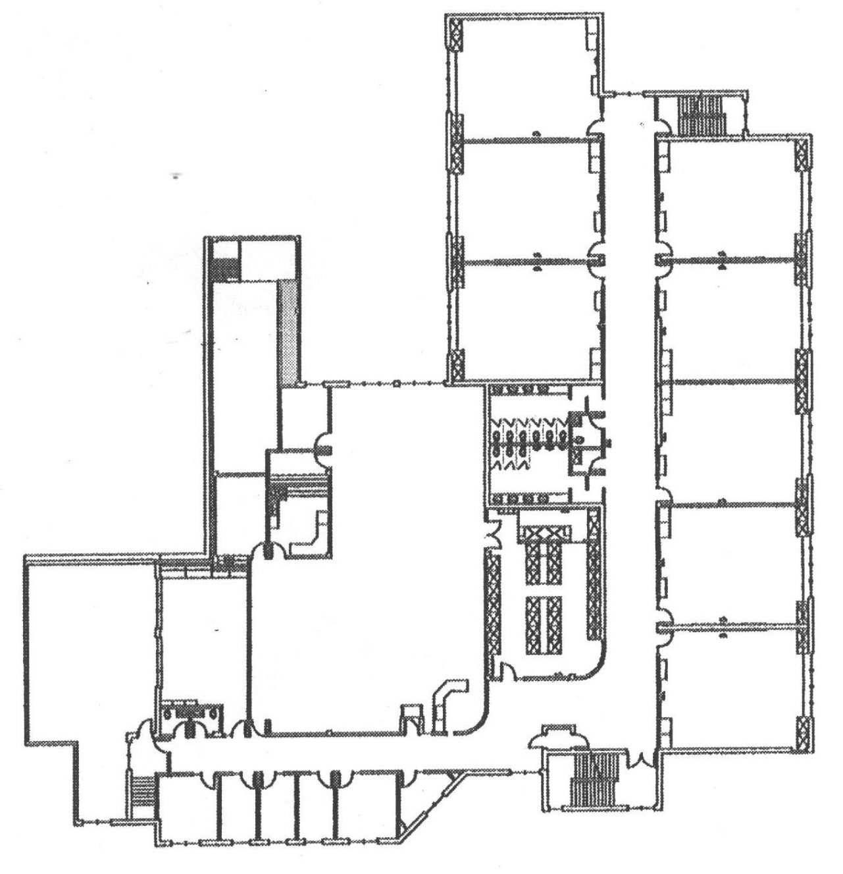
Room 201 – Falkenberg
Room 202 – Learning Support
Room 203 – Hamilton / Sidaway-Wolf
Room 205 – Estabrook – AM /
Muscardin - PM
Room 206 – George
Room 207 – Irving – AM
Room 208 – McDade – S1
Room 209 – Rainbow
Room 210 – Wedge
Room 224 – L. A. classroom:
Andus
Payne – AM
Goodman – S2

Mr. T. Hale
Ms. Seymour
LA Office

Rm 202
Computer Lab

Rm 201

Rm 203

Rm 205

Rm 224
L.A.

LIBRARY

Ms. Estabrook

Rm 207

Rm 206

Rm 208

Rm 209

Rm 210

PCSS Main Floor Room Assignments

Front Entrance

Gymnasium

Main Office
Rm
136
Rm
134
Rm
135
Rm
165
Rm
161
Rm
162
Hemlock Cafe
Rm
101
Rm
103

Rm
105
Rm
107
Rm
109
Staff Room
Rm 104
Rm
106
Rm
108
Rm
111
Rm
113
Rm
115
Rm
108
Rm
110
Rm
118
Rm
117
Rm
120
Rm
119
Rm
125
Rm
166
Rm
167
Rm
168
Rm
150
Rm
148
Rm
146
Rm
149
Rm
147
Rm
145
Rm
143
Rm
141
“The Ram Shack”
Cafeteria
Mr. Susin

Room 101 – Payne PM S1
Price S2
Room 103 – Vermeulen
Room 104 – Foods Rm
Room 105 – Gustafson P2
Room 106 – Mikkelsen AM
Room 107 – Mikkelsen PM
Room 108 – Greve FADS
Room 109 – TBA
Room 110 – Milne S2 Wild
Room 111 – Comeau
Room 113 – Art #2
Room 115 – Hale ART
Room 117 – Riffel METALS
Room 118 – Heal
Room 119 – Beacon WOODS
Room 120 – Payne S2 COSMO
Room 125 – Kelly S1
Room 134 – Fitness/Weight
Room 135 – Moisey BAND
Room 136 – Cameron ABLE
Room 141 – Owen
Room 143 – Cappellano
Room 145 – Ferris
Room 146 – Formaran
Room 147 – Sparling HOPE
Room 148 – Carrey
Room 149 – Dawe
Room 150 – Schroeder
Room 161 – Outdoor Ed.Storage
Room 162 – Milne S1 SASE
Room 162 - McDade S2 SASE
Room 166 – FN Language
Room 167 – FN Cultural Rm
Room 168 – Conference Room
Cafeteria - Sussin

Porter Creek Secondary School
Staff List
2021-2022
Staff Member | Email | Staff Member | Email
Ms. Andrus | kathy.andrus@yesnet.yk.ca | Mr. Moisey | toby.moisey@yesnet.yk.ca
Mr. Beacon | aj.beacon@yesnet.yk.ca | Mr. Monkman | youthsupport@taan.ca
Ms. Boyce | shannon.boyce@yesnet.yk.ca | Mr. Morrison | cody.morrison@yesnet.yk.ca
Ms. Bonnycastle | nicole.bonnycastle@yukon.ca | Mr. Muscardin | matt.muscardin@yesnet.yk.ca
Ms. Burgess | karen.burgess@yesnet.yk.ca | Ms. Owen | marie-eve.owen@yesnet.yk.ca
Ms. Carrey | robin.carrey@yesnet.yk.ca | Ms. Payne | danielle.payne@yesnet.yk.ca
Ms. Chetcuti | brandie.chetcuti@kdfn.net | Mr. Kingdon | anton.riffel@yesnet.yk.ca
Mr. Comeau | andre.comeau@yesnet.yk.ca | Ms. Seymour | joanne.seymour@yukon.ca
Mr. Cook | jason.cook@yesnet.yk.ca | Ms. Sidaway-Wolf | astrid.sidaway-wolf@yesnet.yk.ca
Ms. Cross | nicole.cross@yukon.ca | Ms. Sparling | gina.sparling@yesnet.yk.ca
Ms. Dawe | amy.dawe@yesnet.yk.ca | Ms. Vermeulen | amy.vermeulen@yesnet.yk.ca
Ms. Deo | candice.deo@yukon.ca | Ms. Vigneau | sarah.vigneau@yesnet.yk.ca
Ms. Estabrook | brenda.estabrook@yesnet.yk.ca | Mr. Wedge | logan.wedge@yesnet.yk.ca
Mr. Falkenberg | tim.falkenberg@yesnet.yk.ca | Ms. Witham | samantha.witham@yukon.ca
Ms. Ferris | dagmar.ferris@yesnet.yk.ca | Mr. Saunders | Justin.Saunders@yesnet.yk.ca
Ms. George | jenny.george@yesnet.yk.ca | Mr. Jeffrey Hills | Jeffrey.hills@yukon.ca
Mr. Giangrande | peter.giangrande@yukon.ca
Ms. Graham | jackie.graham@yukon.ca
Ms. Greve | kyla.greve@yesnet.yk.ca
Mr. Gustafson | brad.gustafson@yesnet.yk.ca
Mr. J. Hale | jonathan.hale@yesnet.yk.ca
Mr. T. Hale | trevor.hale@yukon.ca | `
Ms. Hamilton | linda.hamilton@yesnet.yk.ca
Mr. Heal | jerry.heal@yesnet.yk.ca
Ms. Hope | tanya.hope@yesnet.yk.ca
Ms. Hrebien | rachel.hrebien@yesnet.yk.ca
Ms. Irving | treva.irving@yesnet.yk.ca
Ms. Javar | may.javar@yukon.ca
Mr. Kelly | mike.kelly@yesnet.yk.ca
Ms. MacGregor | karen.macgregor@yesnet.yk.ca
Ms. Marks | shannon.marks@yesnet.yk.ca
Mr. Martin | pierre.martin@yesnet.yk.ca
Ms. Mikkelsen | sandra.mikkelsen@yesnet.yk.ca
Mr. Milne | terry.milne@yesnet.yk.ca

Porter Creek Secondary

BELL SCHEDULE
2022 – 2023
8:38 Warning Bell 8:40 PERIOD 1

10:00 Morning Break

10:13 Warning Bell 10:15 PERIOD 2

11:35 Lunch

12:10 Warning Bell 12:15 PERIOD 3

1:35 Afternoon Break

1:43 Warning Bell 1:45 PERIOD 4

3:00 pm Dismissal

August | 2022
Monday | Tuesday | Wednesday | Thursday | Friday | Saturday | Sunday
1 | 2 | 3 | 4 | 5 | 6 | 7
8 | 9 | 10 | 11 | 12 | 13 | 14
15 | 16 | 17 | SEM 1 / TERM 1 START 18 | PD Day 19  Staff Meeting @ 10:00am | 20 | 21
Grade 8 Orientation
1:00-2:15pm
1st Day of School 22 | 23 | 24 | 25 | 26 | 27 | 28
Day 1  Supervision Team A | Day 2 | Day 1 | Day 2 | Day 1
29 | 30 | 31
Day 2  Supervision Team B | Day 1  All City Band Rehearsal 7pm @ PCSS  Sr Band Meet & Social 8-9:30 @ PCSS | Day 2  Dpt Head Meet @ Lunch  YSAA Volleyball Coach Meeting  All City Jr Band Rehearsal 6:30 @ PCSS  Jr Band Info Meet 7:30 @ PCSS
Events | Informal Report Home  Email or phone home.  Sep 12-16th, 2022 | Semester 1  August 18, 2022 – January 16, 2023 | Term 1  August 19, 2022 – October 31, 2022

September | 2022
Monday | Tuesday | Wednesday | Thursday | Friday | Saturday | Sunday
 |  |  | 1 | 2 | 3 | 4
 |  |  | Day 1  Soccer Showdown 1-6pm  Gr 8/9 @ Vanier & Gr 10-12 @ PCSS  Disc Golf (Afternoon)  Gr 8 Band Info Meet 7pm @ PCSS  Instrument Rental Info Meet 7:45 @ PCSS | Day 2
5 | 6 | Pizza Lunch – FADS 7 | 8 | 9 | 10 | 11
LABOUR DAY  NO SCHOOL | Day 1  Supervision Team A  Health & Safety Meeting @ 3:15 | Day 2  Ultimate Frisbee Challenge  Gr 8/9 @ FHC Gr 10-12 @ PCSS | Day 1  SAP @ 8:00AM  1st Jazz Band Rehearsal 3:30-5 @ PCSS | Day 2  VB GR 9/10 Early Bird Tournament @ PCSS | VB GR 9/10 Early Bird Tournament @ PCSS
12 | 13 | 14 | 15 | 16 | 17 | 18
Day 1  Supervision Team B  Cafeteria Opens | Day 2  Staff Meeting @ 3:15 Cafeteria  Squeak & Squawk Night Gr 8 6:45-9 @ PCSS – Senior Band runs the night | Day 1  School Council @ 6:30 | Day 2  Dept Head Meeting @ Lunch  Mtn Bike #1 @ PCSS | Day 1  VB Early Bird Tournament  GR 8 @ Vanier/SR @ PCSS | VB Early Bird Tournament  GR 8 @ Vanier  SR @ PCSS
19  Day 2  Supervision Team A | 20  Day 1 | Pizza Lunch – GSA 21  Day 2 | 22  Day 1  Fire Drill @ 1pm  Supervolley#1 FHC@PCSS  Mtn Bike #2 @ Mt Mac  JR VBall League Girls @ PCSS | Home Room #1 23  Day 2  Terry Fox Run  Gr 8 VC League Girls @ FHC  Supervolley #2 Vanier @ PCSS | 24 | 25
26  Day 1  Supervision Team B | 27  Day 2  School Based Team @ 3:15 | 28  PD Day  School Council @ 6:30 | 29  PD Day | 30  National Day of Reconciliation
Events | TERRY FOX RUN September 23

OPEN HOUSE & HONOUR ROLL
October 5th

October | 2022
Monday | Tuesday | Wednesday | Thursday | Friday | Saturday | Sunday
 |  |  |  |  | 1 | 2
3 | 4 | Pizza Lunch – HOPE 5 | 6 | 7 | 8 | 9
Day 1  Supervision Team A | Day 2  Health & Safety Meet @ 3:15  9/10 Boys VB @ Vanier | Day 1  Open House / Honour Roll  Gr 8 Boys VB @ CSSM | Day 2  Supervolley #3 PCSS @ Vanier | Day 1  Supervolley #4 FHC @ Vanier
10  Thanksgiving  No School | 11  Day 2  Supervision Team B  Staff Meet @ 3:15  9/10 Girls VB @ FHC | 12  Day 1  School Council @ 6:30  GR 8 Girls VB @ FHC | 13  Day 2  Fire Drill @ 8:45 | 14  Day 1 | 15 | 16
17  Day 2  Supervision Team A | 18  Day 1  9/10 Boys VB @ PCSS | Pizza Lunch – Drama 19  Day 2  Dept Head Meet @ Lunch  GR 8 Boys VB @ FHC | 20  Day 1  SAP  Shake Out Earth Quake Drill @10:20  Supervolley #5 Vanier@FHC | 21  Day 2  Supervolley #6 PCSS@FHC  Gr8 Spook&Spike @ PCSS | 22  Gr8 Spook&Spike @ PCSS | 23
24  Day 1 | 25  Day 2  School Based Team @ 3:15 | 26  Day 1  Gr8 Girls Volleyball @PCSS | 27  Day 2  Dawson Invitational Volleyball Tournament | 28  Day 1  Dawson Invitational Volleyball Tournament | 29  Dawson Invitational Volleyball Tournament | 30
END OF TERM 1 31
Day 2
Supervision Team B
Events | Oct 31 – Nov 4  Grade 12 Literacy  Grade 10 & 12 Literacy & Numeracy

November | 2022
Monday | Tuesday | Wednesday | Thursday | Friday | Saturday | Sunday
 | TERM 2 BEGINS 1  Day 1  Health & Safety @ 3:15  9/10 Boys VB @ FHC | Pizza Lunch – PE 2  Day 2  Gr 8 Boys VB @ Vanier | 3  Day 1  SAP @ 8:00  Supervolley Semi-Final @ Vanier  Girls @ 5pm / Boys @ 7pm | 4  Day 2  Supervolley Final @ TBA  Girls @ 5pm / Boys @ 7pm | 5  Jazz Band Retreat | 6
7  Day 1  Supervision Team A | 8  Day 2  Staff Meeting @ 3:15 | 9  Day 1  School Council Meet @ 6:30 | 10  Day 2  Remembrance Day Ceremony  SAP @ 8am | 11  Remembrance Day  No School | 12 | 13
14  Day 1  Supervision Team B | 15  Day 2 | Pizza Lunch – Basketball 16  Day 1  Dept Head @ Lunch | 17  Day 2  Cultural Food Day  9/10 VB Champs @ PCSS/ Gr 8 @ FHC | 18  Day 1  9/10 VB Champs @ PCSS/ Gr 8 @ FHC | 19 | 20
21  Day 2  Supervision Team A | 22  Day 1 | 23  Day 2 | 24  Day 1  Fire Drill @ 1:00  SAP @ 8:00  Sr VB Championships @ FHC | 25  No School  Sr VB Championships @ FHC | 26  Sr VB Championships @ FHC | 27
28  Day 2  Supervision Team B | 29  Day 1  School Base Team @ 3:15 | Pizza Lunch – SASE 30  Day 2
Events | Nov 1 – Nov 8  Progress Reports Due In Office on November 2, 2022 | Nov 23 & Nov 24  Student Lead Conferences

December | 2022
Monday | Tuesday | Wednesday | Thursday | Friday | Saturday | Sunday
 |  |  | 1  Day 1 | 2  Day 2  Share The Spirit  BB 3v3 Gr 8 @ FHC / 9/10 @ PCSS / Sr @ Vanier | 3 | 4
5  Day 1  Supervision Team A | 6  Day 2  Health & Safety @ 3:15  Concert Dress Rehearsals | 7  Day 1  Concert Dress Rehearsals | 8  Day 2  Shaw Memorial BB Tourn @ FHC  Concert Dress Rehearsals | 9  Day 1 | 10 | 11
12  Day 2  Supervision Team B  Music for a Winter’s Eve Concerts 7pm @ Art Centre | 13  Day 1  Staff Meeting @ 3:15  Gr 8 BB Vanier @ FHC / PCSS @ TBA  Music for a Winter’s Eve Concerts 7pm @ Art Centre | Pizza Lunch – WILD 14  Day 2  School Council @ 6:30 | 15  Day 1  Traditional Turkey Dinner & Ugly Sweater Day | 16  Day 2 | 17 | 18
19  Ut'àkwädįch'e Dzenų Nàkwänįitth'ät | 20  JOYEUX NOEL | 21  FROHE WEIHNACHTEN | 22  FELIZ NAVIDAD | 23  MERRY CHRISTMAS | 24 | 25
26  MALIGAYANG PASKO | 27  圣诞节快乐 | 28  ਮੇਰੀ ਕਰਿਸਮਸ | 29  CIID WANAAGSAN | 30  メリークリスマス | 31
Events | INFORMAL REPORTS HOME  Email or Phone Home  December 12th - 16th

January | 2023
Monday | Tuesday | Wednesday | Thursday | Friday | Saturday | Sunday
 |  |  |  |  |  | 1
2 | Back to School 3  Day 1  Supervision Team A  Health & Safety @ 3:15 | 4  Day 2 | 5  Day 1  SAP @ 8:00 | TERM 2 ENDS 6  Day 2 | 7  BB Skagway Tourny | 8  BB Skagway Tourny
9  EXAMS - Semester 1  Supervision Team B | 10  EXAMS - Semester 1  Staff Meeting @ 3:15 | 11  EXAMS - Semester 1  School Council @ 6:30 | 12  EXAMS - Semester 1  Dpt Head Meet @ Lunch  Winter Classic Gr8 @ Vanier / JR @ PCSS | 13  EXAMS - Semester 1  Winter Classic Gr8 @ Vanier / JR @ PCSS | 14  Winter Classic Gr8 @ Vanier / JR @ PCSS | 15
SEM 2/TERM 3 BEGINS 16  Day 1  Supervision Team A | 17  Day 2  Gr 8 BB CSSM @ Vanier / FHC @ PCSS | Pizza Lunch – FADS 18  Day 1  Jr BB CSSM @ Vanier / FHC @ PCSS | 19  Day 2  Fire Drill @ 9:15  Superhoops #1 PCSS  Superhoops#1 PCSS vs Vanier  Girls @5pm/ Boys @7pm | 20  Day 1  Superhoops#2 FHC vs Vanier  Girls @5pm/ Boys @7pm | 21 | 22
23  Day 2  Supervision Team B | 24  Day 1  Gr8 BB Vanier @ FHC / PCSS @ CSSM  Sr Band Info Meet 8:30 @ FHC | 25  Day 2  Jr BB Vanier @ FHC / PCSS @ CSSM  Jr Band Info Meet @ 7:30 @ FHC | 26  Day 1  Gr 8 Band Info Meet 7pm @ FHC  Instrument Rental Info Meet 7:45 @ FHC | 27  Day 2 | 28  Lights Out Tournament | 29  Lights Out Tournament
30  Day 1  Supervision Team A | 31  Day 2  School Based Team @ 3:15
Events | Jan 23rd – Jan 27th  Grade 10 & 12 Literacy & Numeracy | FINAL REPORTS DUE TO OFFICE JANUARY 11TH | ALL REPORTS DUE IN ASPEN JANUARY 18TH

February | 2023
Monday | Tuesday | Wednesday | Thursday | Friday | Saturday | Sunday
 |  | Pizza Lunch – GSA 1  Day 1 | 2  Day 2  SAP @8:00  Superhoops #3 Vaniers vs PCSS | 3  Day 1  Dpt Head Meet @ Lunch  Superhoops #4 FHC vs PCSS | 4 | 5
6  Day 2  Supervision Team B | 7  Day 1  Health & Safety @ 3:15  Gr.8 BB PCSS @ Vanier / CSSM @ FHC  Squeak & Squawk Night Gr 8 6:45-9 @ PCSS – Senior Band runs the night | 8  Day 2  School Council @ 6:30  Jr BB PCSS @ Vanier / CSSM @ FHC | 9  Day 1  Earthquake Drill @10AM  Superhoops #5 Vanier vs FHC | 10  Day 2  Superhoops #6 PCSS vs FHC | 11  Dessert & Dance – Mt. McIntyre | 12
13  Day 1  Supervision Team A | 14  Day 2  Staff Meeting @ 3:15  Valentines Dance | Pizza Lunch – HOPE 15  Day 1 | 16  Day 2  SAP @8:00  Gr.8 & Jr Champs @PCSS/Vanier | 17  Day 1  Gr.8 & Jr Champs @PCSS/Vanier | 18  Gr.8 & Jr Champs @PCSS/Vanier | 19
20  Day 2  Supervision Team B | 21  Day 1 | 22  Day 2  Superhoops Semi-Final @ Vanier | 23  Day 1  Superhoops FINAL @ Vanier | 24  Heritage Day  No School | 25  Jazz Band @ Rendezvous TBC | 26
27  Day 2  Supervision Team A | 28  Day 1  School Based Team @ 3:15
Events | INFORMAL REPORTS HOME  Email or Phone Home  February 13th - 17th

March | 2023
Monday | Tuesday | Wednesday | Thursday | Friday | Saturday | Sunday
 |  | Pizza Lunch – Drama 1  Day 2 | 2  Day 1  SAP @8:00  Sr BB Championships @ FHC | 3  Day 2  Sr BB Championships @ FHC | 4  Sr BB Championships @ FHC | 5
6 | 7 | 8 | 9 | 10 | 11 | 12
Day 1  Supervision Team B | Day 2  Staff Meeting @ 3:15 | Day 1  School Council @ 6:30 | Day 2  Gr 8 Band Retreat | Day 1  Gr 8 Band Retreat
13  S | 14  P | 15  R | 16  I | 17  N | 18  G | 19
20  B | 21  R | 22  E | 23  A | 24  K | 25 | 26
27  Day 2  Supervision Team A | 28  Day 1 | 29  Day 2 | 30  Day 1  SAP @ 8:00 | 31  Day 2  HOME ROOM  &  WINTER CARNIVAL

April | 2023
Monday | Tuesday | Wednesday | Thursday | Friday | Saturday | Sunday
 |  |  |  |  | 1 | 2
3  Day 1  Supervision Team B | 4  Day 2  Health & Safety @ 3:15 | Pizza Lunch – Basketball 5  Day 1  Badminton Drop-In Competition @ Vanier | Term 3 Ends 6  Day 2  SAP @ 8:00 | 7  Good Friday | 8  Jazz Band Community Tour | 9  Jazz Band Community Tour
10  Easter Monday | 11  Day 1  Supervision Team A  Term 4 Starts  Staff Meeting @ 3:15  Sr Band Elementary Concerts Tour | 12  Day 2  School Council @ 6:30  Badminton Drop-In Competition @ PCSS  Jr Band Elementary Concerts Tour | 13  Day 1  Gr 8 Elementary Concerts Tour | 14  Day 2  PROGRESS REPORTS DUE IN OFFICE | 15 | 16
17  Day 1  Supervision Team B | 18  Day 2 | Pizza Lunch – SASE 19  Day 1  Student Lead Conference  Badminton Drop-In Competition @ FHC & CSSM | 20  Day 2  Fire Drill @ 1pm  Student Lead Conference  SAP @ 8:00 | 21  No School | 22 | 23
24  Day 1  Supervision Team A | 25  Day 2  School Based Team @ 3:15  Gr 8 FHC & PCSS Combined Rehearsal @ FHC  Concert Dress Rehearsal | 26  Day 1  Concert Dress Rehearsal | 27  Day 2  Concert Dress Rehearsal | 28  Day 1  Concert Dress Rehearsal | 29 | 30
Events | April 11th – 14th  Progress Reports Due In Office on April 14th, 2023 | April 24th – April 28th  Grade 10 & 12 Literacy & Numeracy

May | 2023
Monday | Tuesday | Wednesday | Thursday | Friday | Saturday | Sunday
1  PD Day  Sounds of Spring Concert 7pm @ Yukon Arts Centre National “Music Monday” | 2  Day 2  Supervision Team B  Health & Safety @ 3:15 | 3  Day 1  Senior Band Pop Concert At Shipyards Park TBC | 4  Day 2  SAP 8:00 | 5  Day 1  Carmacks Ridge Run | 6 | 7
8  Day 2  Supervision Team A | 9  Day 1  Staff Meeting @ 3:15 | Pizza Lunch – WILD 10  Day 2  School Council @ 6:30  Beach VB @ FHC/CSSC | 11  Day 1  3vs3 BB @ PCSS | 12  Day 2  Vanier Run | 13 | 14
15  Day 1  Supervision Team B | 16  Day 2 | 17  Day 1  Beach VB @ FHC/CSSC | 18  Day 2  SAP 8:00  3vs3 BB @ Vanier | 19  Day 1 | 20 | 21
22  Victoria Day  No School | 23  Day 2  Supervision Team A | Pizza Lunch – FADS 24  Day 1  Track & Field Meet | 25  Day 2 | 26  Day 1  Haines Junction Forestry Run | 27 | 28
29  Day 2  Supervision Team B | 30  Day 1  School Based Team @ 3:15 | 31  Day 2
Events | INFORMAL REPORTS HOME  Email or Phone Home  May 15th - 19th

June | 2023
Monday | Tuesday | Wednesday | Thursday | Friday | Saturday | Sunday
 |  |  | 1  Day 1  SAP @ 8:00  High School Softball Challenge | 2  Day 2  High School Softball Challenge | 3 | 4
5  Day 1  Supervision Team A  Jazz Band Arts in the Park TBC | 6  Day 2 | TERM 4 ENDS 7 | 8  EXAMS | 9  EXAMS | 10 | 11
12  EXAMS | 13  EXAMS | 14  MAKE-UP EXAMS  CAP & GOWN | 15  LAST DAY OF SCHOOL | 16 | 17 | 18
19 | 20 | 21 | 22 | 23 | 24 | 25
26 | 27 | 28 | 29 | 30
Events | FINAL REPORTS DUE TO OFFICE JUNE 9TH | ALL REPORTS DUE IN ASPEN JUNE 14TH

