How to Access Google Classroom

First, Access Rapid ID

https://portal.yesnet.yk.ca/
​
or
​
https://v2yesnet.wordpress.com/ and click on "SINGLE SIGN ON"
​
​
If students have logged in before, they need to use their own student number username (studentnumber@yesnet.yk.ca) and the password they have previously created.

If they forgot the password, email the teacher to request a reset. If they have forgoten their student number, please contact the teacher.
​
If the student has NEVER logged in to Rapid ID, they will need to set up the login using their student number username and a default password. How to do that can be found at this link: https://v2yesnet.files.wordpress.com/2020/04/rapid-id-first-log-in-instructions.pdf
​
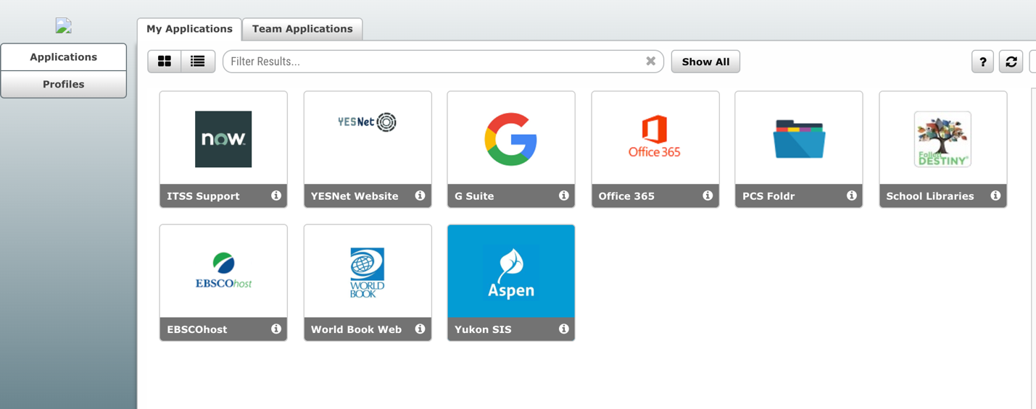
Once students have accessed Rapid Identity, they should see a number of apps, one of which is the G Suite app.

Clicking on the G Suite should open Google Drive. In the top right hand corner they can click on the grid button to see other google apps, and select Google Classroom from there.

Stuck? Watch this video:

https://www.youtube.com/watch?v=xfgqtCi7hdo

